DAY8 SESSION ASSIGNMENTS (Theory)

- When to use (Rapid Application Development) RAD model When not to use (Rapid Application Development) RAD model
RAD (Rapid Application Development) is an adoption of waterfall model which aims at developing a software in a short span of time. It has different phases like Define, Analyze, Design, Develop, Test and Support. It concentrated on the input and output source and destination of information.

The RAD model can be used

- When the project can be modularized.
- When there is higly skilled designers, domain experts.
- To get higher productivity with fewer people in short time.
- When requirements can be changed.
- When responding to changes is encouraged and changes have to be reflected in the product.
- If there’s high availability of designers for modeling and the budget is high enough to afford their cost along with the cost of automated code generating tools.
- It should be used only if the budget permits use of automated code generating tools.
- Should be used where the requirements change during the course of the project and working prototypes are to be presented to customer in small iterations of 2-3 months.

The RAD model should not be used

- When there is not a strong team who does not know business requirements.
- When the system cannot be modularized.
- When there are no highly skilled domain experts.
- If it is a cheaper project.

- Define an ER diagram of a software Organization with all the relationship model that was discussed in the classroom

ER is the Entity Relationship diagram. An entity-relationship diagram is a graphical representation of an information system that shows the relationship between people, objects, places, concepts or events within that system. An ER diagram is a data modeling technique that can help define business processes and can be used as the foundation for a relational database.

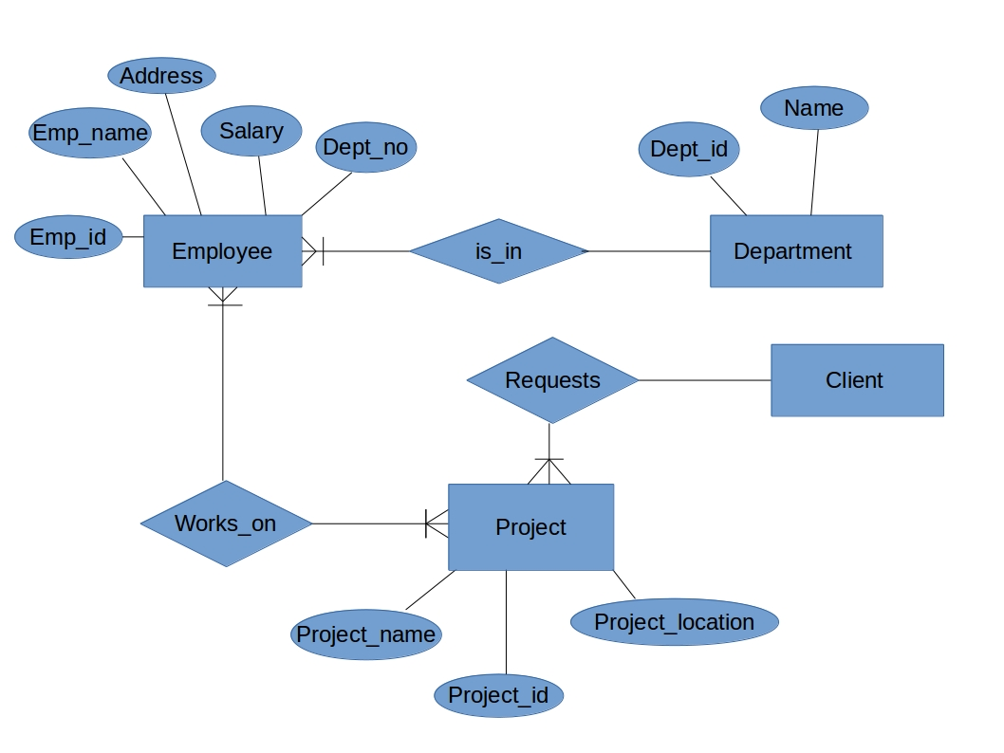

- Describe the Entity Relationships for the following diagram

- The entities are
1. Login Details
2. Admin
3. Leave details
4. Staff details
- Three Attributes for Login details
- Leave details has attributes: Type, Leave id, Status, Staff id, Apply date, From date, To date
- Staff details has attributes: Staff id, Staff name, Username, Contact
- Login details and Admin has a Many-to-Many relationship which is a has relationship
- Staff details and Leave details has a Many-to-Many relaionship which is applies for relationship
- Admin and Staff details has a Many-to-Many relationship where the relationship is Add new
- Admin and Leave details has a Many-to-Many relationship where the relationship is Access the details of Leave.

